- Create a simple cloud software application for Property Buying &amp; Rental process (In Chennai city) using any Cloud Service Provider to demonstrate SaaS.

Aim

To create a simple cloud-based Property Buying and Rental application for Chennai city using a Cloud Service Provider and demonstrate the Software as a Service (SaaS) model.

Procedure
- Log in to a cloud platform (AWS, Azure, or Google Cloud).
- Create a simple property buying and rental application.
- Add property details such as location, price, and type.
- Store the data in a cloud database.
- Deploy the application on the cloud.
- Open the application in a web browser and test the property search and booking features.
Floe Chart:
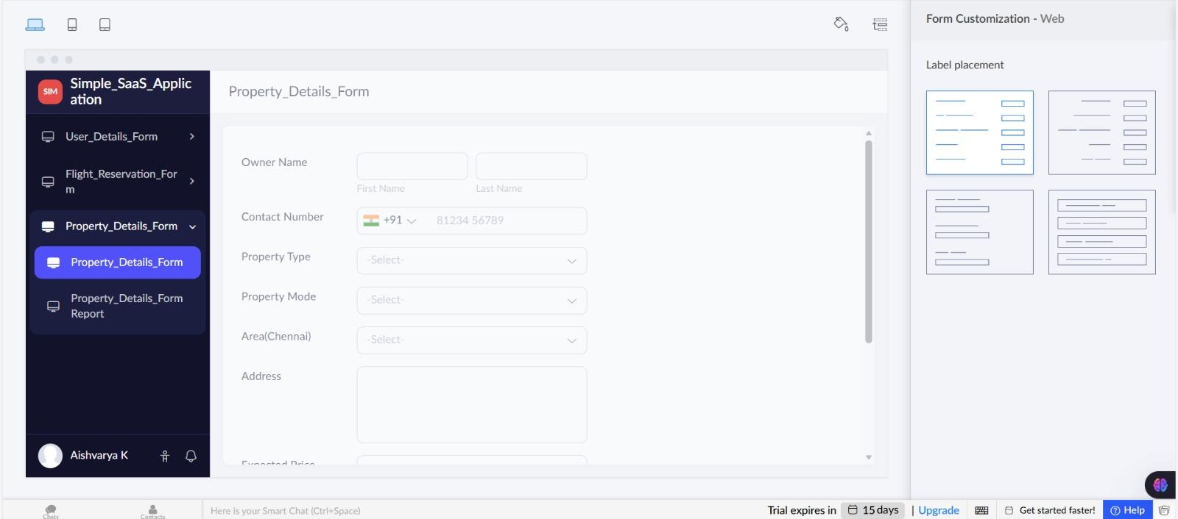

Result
The Property Buying and Rental application for Chennai city was successfully created and deployed on the cloud. Users can access property information and submit rental or purchase requests through the internet, demonstrating the SaaS model.

